**REST - Get country based on country code**   
  
  
**Controller**: com.cognizant.spring-learn.controller.CountryController  
**Method Annotation:** @GetMapping("/countries/{code}")  
**Method Name**: getCountry(String code)  
**Method Implemetation**: Invoke countryService.getCountry(code)   
**Service Method:**com.cognizant.spring-learn.service.CountryService.getCountry(String code)  
  
**Service Method Implementation**:

* Get the country code using @PathVariable
* Get country list from country.xml
* Iterate through the country list
* Make a case insensitive matching of country code and return the country.
* Lambda expression can also be used instead of iterating the country list

**Sample Request**: http://localhost:8083/country/in  
  
**Sample Response**:

{

  "code": "IN",

  "name": "India"

}

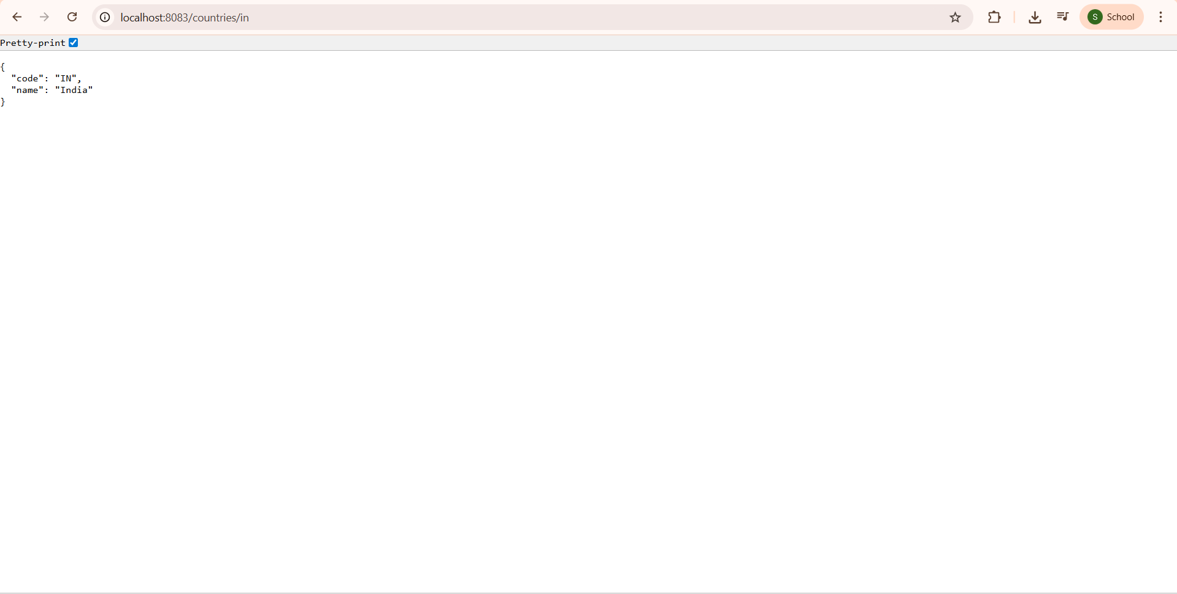

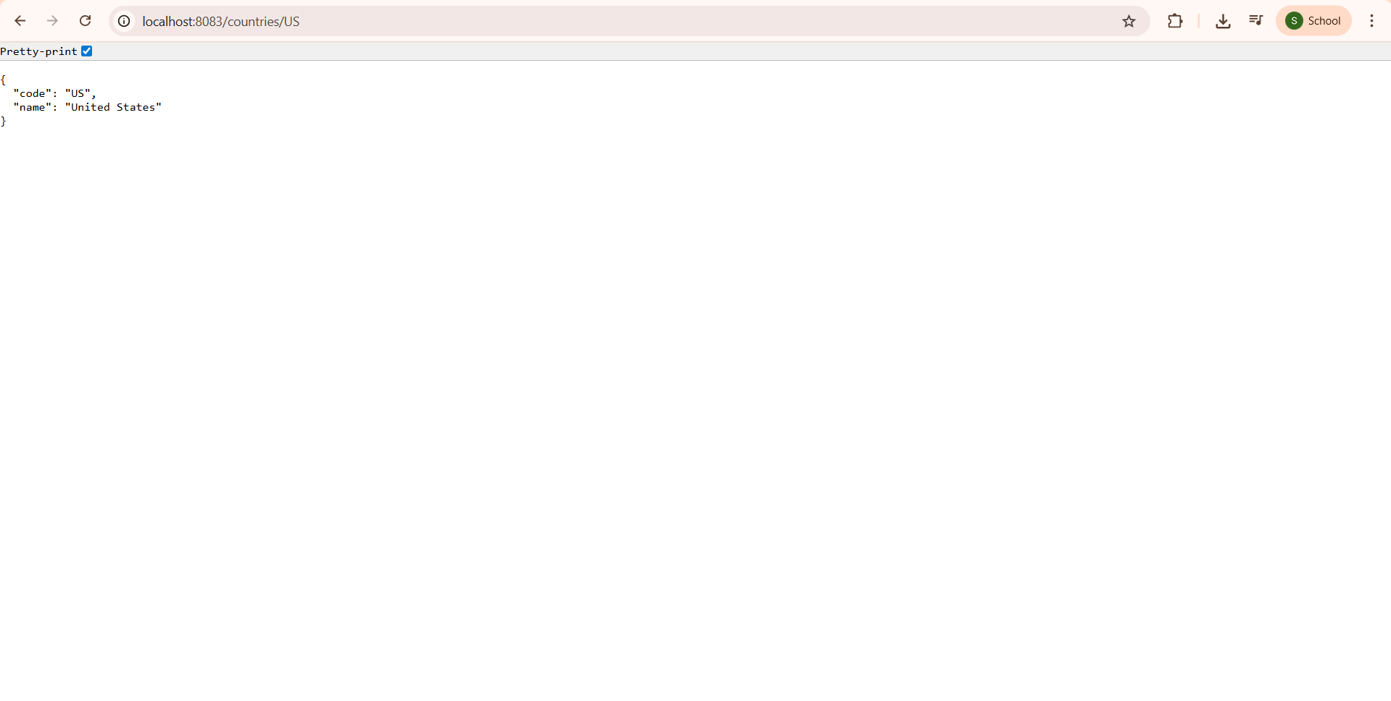

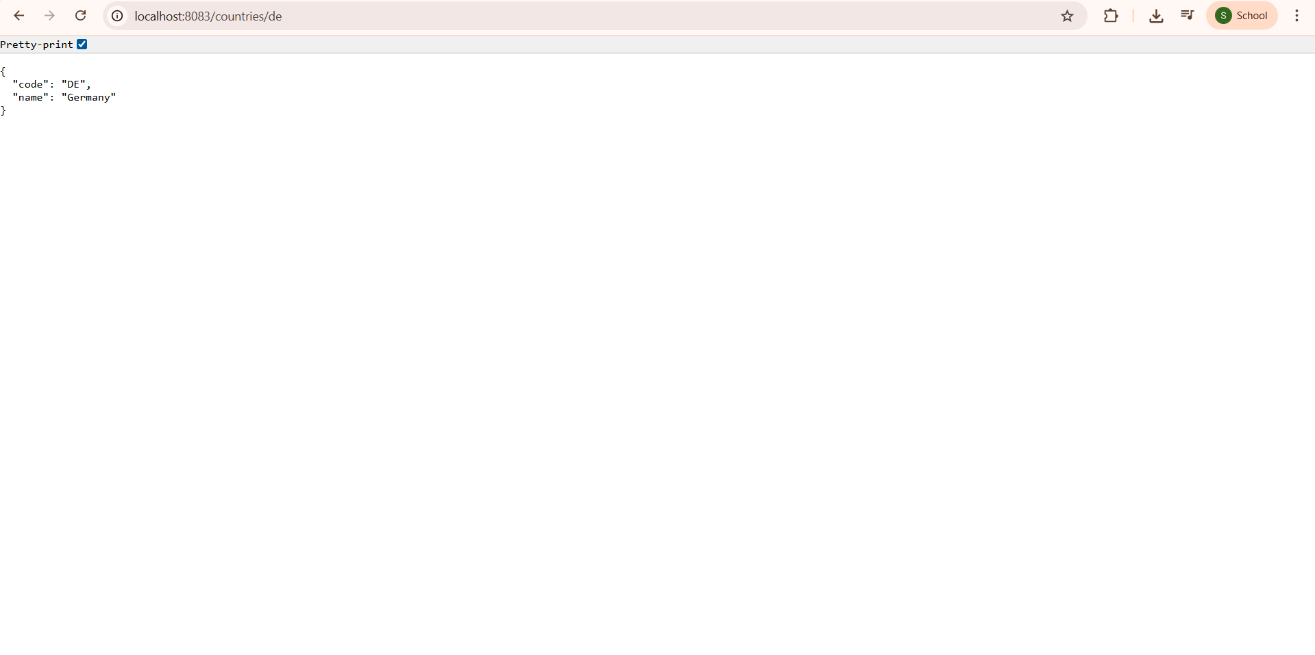

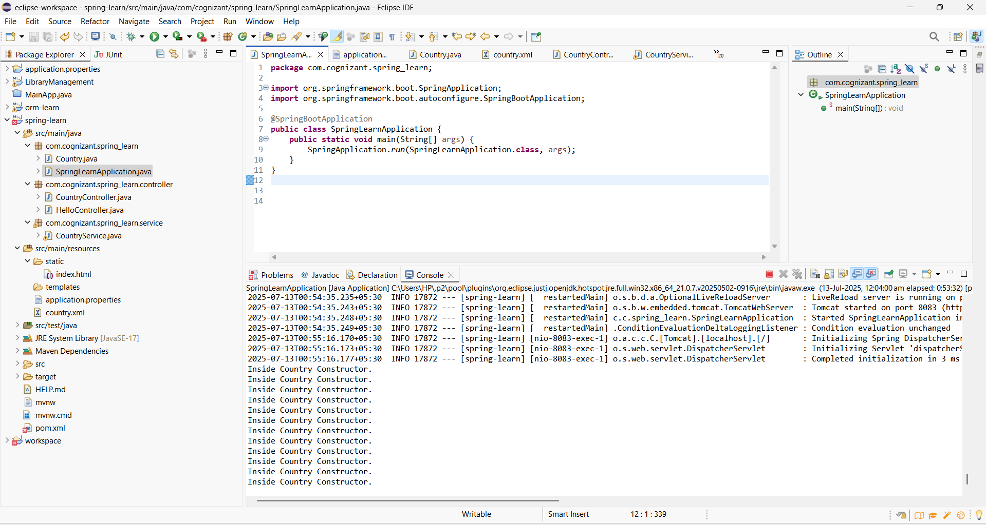

**COUNTRYSERVICE.JAVA**

package com.cognizant.spring_learn.service;

import com.cognizant.spring_learn.Country;

import org.springframework.context.ApplicationContext;

import org.springframework.context.support.ClassPathXmlApplicationContext;

import org.springframework.stereotype.Service;

import java.util.List;

@Service

public class CountryService {

public Country getCountry(String code) {

ApplicationContext context = new ClassPathXmlApplicationContext("country.xml");

List<Country> countries = (List<Country>) context.getBean("countryList");

return countries.stream()

.filter(c -> c.getCode().equalsIgnoreCase(code))

.findFirst()

.orElse(null); // You can throw an exception if preferred

}

}